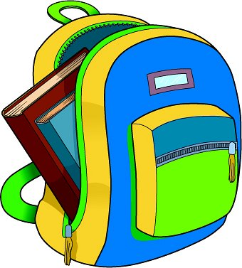
2024
FBA 1st Grade Supply List

- Fiskars “For Kids” scissors (5” pointed tip)
- Primary Journal Composition notebook
- Pocket folder without prongs (red and blue)
3- Box of tissues
2- 24 count Pack of #2 pencils (Ticonderoga brand)
- Plastic pencil box
1- Ruler, 12”, plastic (non-bending, please)
2-Clorox disinfecting wipes (75 count)
1- Pack dry erase markers (black)
2- Packs of Elmer’s glue sticks (2count)
- Boxes of Crayola brand crayons (24 ct.)
- Pack of white index cards
- Clipboard
1 pack baby wipes
1 box band-aids (Boys only)
1 box gallon size Ziploc bags (Boys only)
1 bottle of Lysol spray (Girls only)
1 box of Ziploc sandwich bags (Girls only)

A pencil box will be provided for your child, but please label the following items with your child’s name and if some of the above items are still in good condition from last year, please feel free to use again…
notebooks, clip boards, lunch box, and folders


