**2024**

**FBA 3rd Grade Supply List**

2 composition notebooks, wide-ruled (one preferably black)

1 box of crayons (24 count)

1 box of markers

1 – 24 pack of Ticonderoga brand no. 2 pencils

2 large erasers

1 pack of colored pencils

1 pack of index cards

6 glue sticks

2 bottles of Clorox wipes (75 count)

2 pack dry erase markers (1 color pack and 1 black pack)

3 boxes of Kleenex

1 box sandwich bags

1 box gallon size bags

1 pack baby wipes

1 roll paper towels

*Scissors

*Ruler (with centimeters and millimeters)

*Pencil pouch (please no boxes for space purposes)

*ESV student Bible

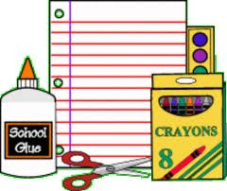*Please note that if you have any of these items from last year and they are in good condition, feel free to re-use.