2024
FBA Kindergarten Supply List

- Fiskars “For Kids” scissors (5” pointed tip)
3- Box of tissues
4- Clorox disinfecting wipes (75 count)
- Box of quart size Ziploc bags (boys only)
- Box gallon size Ziploc bags (girls only)
1- Pack of Primary color washable markers (Large markers/no fine tip)
4- Boxes of Crayola Crayons (24 count and contains primary colors)
3- Rolls of paper towels
- Pack of baby wipes
8- Glue sticks
- Pack of paper plates
- Box of spoons
- Box of forks
- Pack of No. 2 Ticonderoga Pencils
- Bottles of hand sanitizer

A pencil box WILL be provided for your student, but
Please label the following items with your child’s name….

Scissors
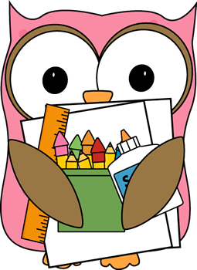
Book bag
Lunch box
Markers (label the box)

Please bring supplies to Open House on
August 6!

